The Implementation-Art workbook
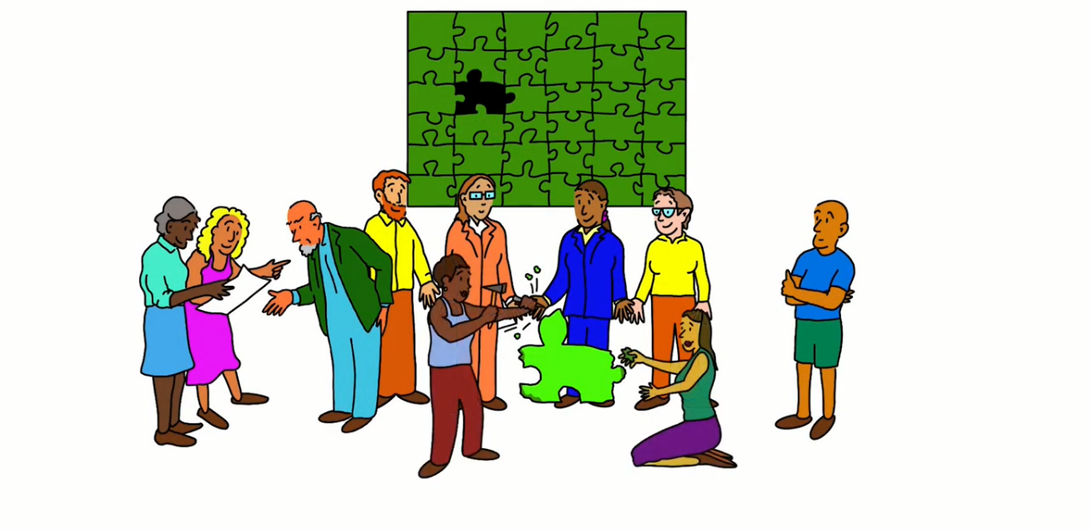
How should one go about implementing health and care research?
A guide to the structured process adopted in NIHR ARC East of England is in this virtual art gallery artsteps.com/view/6221f2fe017c5132ba1d14d0/, and a PDF version is available on the ARC EoE website arc-eoe.nihr.ac.uk/gallery.
If you are someone leading implementation or a major participant in the implementation process, then you can use this workbook to record your own answers to the questions posed by the exhibits in the gallery or on the website and so make plans for your own project. Of course you can adapt it to best suit your own needs.

In a nutshell: implementing through facilitated communities of practice
A design group (3-5 key stakeholders, to take the project from start to finish):
- decides if the evidence is relevant, robust, and ready to implement
- gathers first thoughts on the context
- identifies which people need to be involved
- sources the skills required by the method
- convenes the Community of Practice.
The Community of Practice (up to 20 people, representative and inclusive of all key stakeholders):
- assesses the research findings
- analyses claims and concerns
- formulates the implementation plan
- makes small tests of change
- rolls out the successful changes and takes learning forward.
Contents
Tips on appraising evidence 3
Tips on understanding the context 7
The target people 11
The change method 12
The first design group meeting 13
Tips on engaging people 14
Invitation to the Community of Practice 17
Creating the best environment for the Community of Practice 18
Tips on setting success criteria 19
Tips on evaluation 20
Tips on impact assessment and communication 21
Appendix: Research implementation: other approaches 23
Appendix: The Badchester Chronicles 27

Tips on appraising evidence
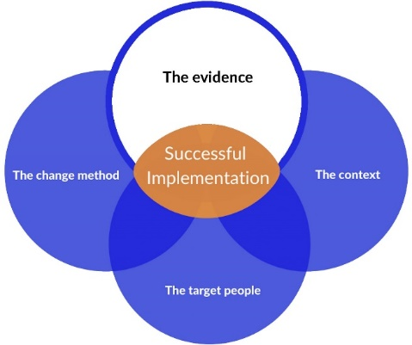 | Relates to Exhibits 2 and 20 ‘The evidence’ (Rooms 1 and 3) and ‘Tips on appraising evidence’ (in the Top tips display room).
You need to appraise the research evidence you have for robustness, relevance and readiness for implementation. You also need to appraise other sorts of evidence that might be merged with the research evidence during implementation.

Robustness of research evidence

Which of the checklists from CASP, the Critical Appraisal Skills Programme in Oxford (casp-uk.net/casp-tools-checklists/), are appropriate to the research that you are thinking about implementing?

Systematic Reviews |  |  | Economic Evaluations
Randomised Controlled Trials |  |  | Diagnostic Studies
Cohort Studies |  |  | Qualitative Studies
Case Control Studies |  |  | Clinical Prediction Rule

Assess the research with your chosen checklist(s). (You might have to look beyond CASP if these checklists do not cover the design of the study.)

Other kinds of evidence
People do not base their actions just on research evidence but on all sorts of other forms of evidence including their own and others’ experience – see the poster and video on ‘mindlines’ in the Top tips display room and consider how people’s existing mindlines might affect the implementation process.

Use the table overleaf to help you assess some of the other forms of evidence.

Assessing the rigour of evidence – some initial elements for consideration
Research-based evidence | Own experiences | Theoretical perspectives (non-research-based) | Clients’/Patients’/Carers’ experiences | Role models’/experts’ opinions | Policy directives
Link between research and clinical situation  Strengths and weaknesses of design in relation to aims of research  Reliability and validity / credibility  Appropriateness of findings to clinical issue  Appropriateness of recommendations for practice  How this research fits in with other findings  Likelihood of transferability to practice setting  Evidence of use elsewhere or evaluation of impact | Relevance to the clinical situation  Frequency/uniqueness of experience  Extent to which experience has been rigorously subjected to critical reflection / audit  Extent to which experiences have been shared by others  Extent to which other sources of evidence support experiences  Extent of transferability of experiences to current situation | Link between theory and clinical situation  Strengths and weaknesses of argument being presented  What sources of evidence are used?  Credibility / face validity  How this theory measures up to other theories  Appropriateness of theory to clinical issue  Appropriateness of recommendations for practice  Likelihood of transferability to practice setting  Evidence of successful use elsewhere or evaluation of impact | Relevance to the current situation  Frequency/uniqueness of experience  Extent to which experiences have been shared by others  Extent to which other sources of evidence support experiences  Richness of the description  Extent of transferability of experiences to current situation | Depth and breadth of expertise  Credibility / reputation  Face validity of advice  Reason for choice – what defines expertise?  What sources of evidence are drawn upon to support knowledge?  Relevance of advice to current situation  Likelihood of transferability of evidence to practice setting  Evidence of use elsewhere or evaluation of impact | Possible conflict of interest of policy makers vis à vis this clinical situation  Type and strength of evidence used to support directive(s)  Relevance to current situation or clinical issue  Currency – date when last reviewed  Likelihood of transferability to practice setting  Evidence of use elsewhere or evaluation of impact
Andrée le May and John Gabbay, ‘Evidence-based practice – more than research needed!’ in George T. Lewith, Wayne B. Jonas and Harald Walach (eds), Clinical Research in Complementary Therapies: Principles, Problems and Solutions (Edinburgh, Elsevier, 2011), pp. 391–406. © Elsevier Ltd 2011

Relevance of research evidence

Ask key stakeholders if the research findings will be useful to clients, staff and/or systems.

 | Questions to ask yourself |  | Your answers
Who will you ask?
(If the people you know best are not well-placed to give you good answers, could they introduce you to other people?)
What is your ‘elevator pitch’?
(Summarise in no more than three sentences why this research would be beneficial to the organisation.)
What will you respond if they ask how you are proposing to implement the research?
(Write your own summary of the outline implementation process.)

 | Evaluate the relevance of the research evidence
What were the responses of these stakeholders?  Do they justify the conclusion that the research is relevant?  Did they suggest further investigation or consultation? If so, when and how will you do it?  Are there relevant local data (e.g. audit or activity data) that could help inform the decision? |  | If the responses indicate low relevance/ willingness, is there other research that might be more relevant to those organisations? Or other organisations to which this research might be more relevant?

Readiness of research evidence

 | Questions to ask yourself |  | Your answers
What else has been written about this research? (For example, are there any citations you can follow up?)
What do these writings tell you about the readiness of the research for implementation?
Is there any indication that any other organisation has tried to implement it? Any lessons from their experience?
Who else can I ask if they are aware of implementation elsewhere?
What do they tell me?

Tips on understanding the context
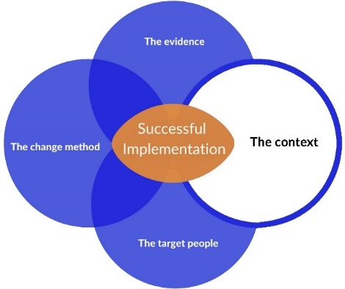 | Relates to Exhibit 3 ‘The context’ (Room 1) and ‘Tips on understanding the context’ (in the Top tips display room).
Mapping the context with other people is useful as they will have access to other sources of information – and so widen your understanding.

 | Question to ask yourself |  | Your answer
Who can you work with to map the context?

Map the context using one of the tools overleaf.

External context map headings

Political climate | Economic climate | Environmental trends
 | Social climate
Technology trends | Cultural trends | Uncertainties
Source: Mobilisation Lab. See mobilisationlab.org/resources/context-map/ for a downloadable graphic version of this map, in A4 and A0 sizes.

Internal context map headings

 | Working norms
Pressures | Resources | Skills | Constraints
 | Culture | Internal relationships

Consolidated Framework for Implementation Research constructs
For more explanation, see cfirguide.org/
Outer setting

Construct | Short description | Your notes on the organisation
Patient needs and resources | The extent to which patient needs, as well as barriers and facilitators to meet those needs, are accurately known and prioritized by the organisation.
Cosmopolitanism | The degree to which an organisation is networked with other external organisations.
Peer pressure | Mimetic or competitive pressure to implement an intervention; typically because most or other key peer or competing organisations have already implemented or are in a bid for a competitive edge.
External policies and incentives | A broad construct that includes external strategies to spread interventions, including policy and regulations (governmental or other central entity), external mandates, recommendations and guidelines, pay-for-performance, collaboratives, and public or benchmark reporting.
Source: cfirguide.org/constructs/
Inner setting

Construct | Short description | The organisation
Structural characteristics | The social architecture, age, maturity, and size of an organisation.
Networks and communications | The nature and quality of webs of social networks and the nature and quality of formal and informal communications within an organisation.
Culture | Norms, values, and basic assumptions of a given organisation.
Implementation climate | The absorptive capacity for change, shared receptivity of involved individuals to an intervention, and the extent to which use of that intervention will be rewarded, supported, and expected within their organisation.
Tension for change | The degree to which stakeholders perceive the current situation as intolerable or needing change.
Compatibility | The degree of tangible fit between meaning and values attached to the intervention by involved individuals, how those align with individuals’ own norms, values, and perceived risks and needs, and how the intervention fits with existing workflows and systems.
Relative priority | Individuals’ shared perception of the importance of the implementation within the organisation.
Organisational incentives and rewards | Extrinsic incentives such as goal-sharing awards, performance reviews, promotions, and raises in salary, and less tangible incentives such as increased stature or respect.
Goals and feedback | The degree to which goals are clearly communicated, acted upon, and fed back to staff, and alignment of that feedback with goals.
Learning climate | A climate in which: a) leaders express their own fallibility and need for team members’ assistance and input; b) team members feel that they are essential, valued, and knowledgeable partners in the change process; c) individuals feel psychologically safe to try new methods; and d) there is sufficient time and space for reflective thinking and evaluation.
Readiness for implementation | Tangible and immediate indicators of organisational commitment to its decision to implement an intervention.
Leadership engagement | Commitment, involvement, and accountability of leaders and managers with the implementation.
Available resources | The level of resources dedicated for implementation and on-going operations, including money, training, education, physical space, and time.
Access to knowledge and information | Ease of access to digestible information and knowledge about the intervention and how to incorporate it into work tasks.
Source: cfirguide.org/constructs/

The target people
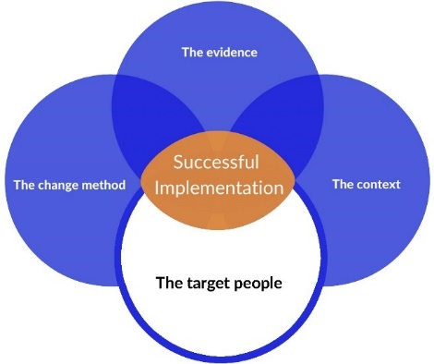 | Relates to Exhibits 4 and 21 (Rooms 1 and 3). See also ‘Tips on engaging people’ below.

 | Question to ask yourself |  | Your answer
What groups of people will you need to work with? (e.g. practitioners, patients, carers, managers, commissioners, …?)

Capture your expectations of each group

Group | What do you expect their views to be? How could you get them to share their views openly?

The change method
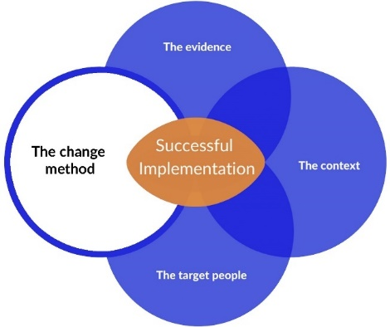 | Relates to Exhibits 5 and 22 (Rooms 1 and 3).

Watch the video ‘How research implementation works’ (Exhibit 6, Room 1).

 | Questions to ask yourself |  | Your answers
What challenges can you anticipate?
What are the strengths and assets you have to work with?
What benefits and opportunities can you use to engage and motivate people?
What skills are needed? For any you don’t have yourself, who else can supply them?
What knowledge, experience, and access are needed? Who can supply them?
What funding sources may there be? How long do they last?
What reporting requirements may there be?
What timescale are you working to? Are there any critical dates you need to hit? Is this timescale realistic?

The first design group meeting
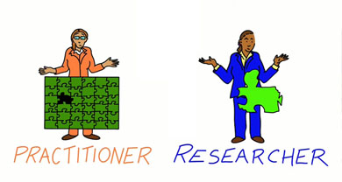 | Relates to Exhibit 13 (Room 2) ‘The first design group meeting’.

Invite 3-4 key stakeholders to join you as a design group to guide the project from start to finish, and plan what you need to do with the group in your first meeting.

 | Suggested agenda item (adapt as required) |  |  | How will you do this?
Present the research and why you think it should be implemented. Get initial reactions.
Ask if members know about the research, if they’ve heard of it being used elsewhere.
Consider if the research EVIDENCE is ready to implement. |  |  | Do you need to do any pre-work? Such as:  - find out more about the research and how the researcher thought it might be implemented – ask the researcher to talk to the design group (virtually / in person)  - find out if the research has been used by others – Google the topic, ask colleagues.  Perhaps as a group think through how you could try it out initially to see if it works (see ‘Tips on evaluation’).
Check if you need funds to get the research implemented. Where might they come from?
Gather first thoughts on whether the CONTEXT will be receptive to the research.
Identify which PEOPLE need to be involved in the implementation of the research.
Explain about Communities of Practice. |  |  | For example, show ‘How research implementation works’ (Room 1, Exhibit 6) or Chris Collinson’s video youtube.com/  watch?v=1Pxd6ixU9kk – a paella analogy.
Discuss the SKILLS needed (facilitation, evaluation etc.) and who might have them.
If you decide to go ahead you can begin to plan your Community of Practice. However, sometimes the right decision is NOT to go ahead!

Tips on engaging people
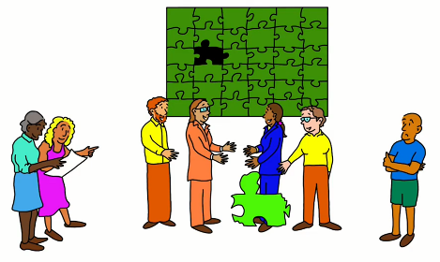 | Relates to Exhibit 21 (Room 3) ‘The target people’ and ‘Tips on engaging people’ (in the Top tips display room).
You need to really understand who wants you to implement the evidence and why. You can do this by chatting and watching what’s going on in the organisation. At the same time, you can also check how robust and relevant the research evidence seems to those who will be expected to implement it; this will play an important part in your subsequent work with them.

Work out the drivers for / barriers to implementation, by picking a few key people in the organisation and exploring (through chats / observations) the context within which the evidence will be implemented.

Name of person: | What do they want to achieve through implementing this evidence (assuming they are in favour of doing so)? and why?
 | What do they think the potential impact could be?
 | What / who might stand in the way of achieving it? Why is that?
 | When do they want it achieved by?
 | Who do they think can help this process (or hinder it) – and should be involved?
 | If this person is against it, why is that?

Name of person: | What do they want to achieve through implementing this evidence (assuming they are in favour of doing so)? and why?
 | What do they think the potential impact could be?
 | What / who might stand in the way of achieving it? Why is that?
 | When they want it achieved by?
 | Who they think can help this process (or hinder it) – and should be involved?
 | If this person is against it, why is that?
(Copy this table as many times as required)

Define the wider group of stakeholders – people who will be involved in or benefit from the implementation project – with the help of some of these key people that you’ve been getting to know.

Person / group / organisation | What they will bring (positive or negative) | What will motivate them (or demotivate them)
Can you involve the researchers in some way?

Develop an engagement strategy for each of the stakeholder groups, using tools such as the ones below.
There are many websites that take you to a stakeholder analysis, for example mindtools.com/pages/article/newPPM_07.htm
A common technique is to map stakeholders on a Power / Interest grid:
- those with high power and high interest, you should manage closely
- those with high power and low interest, you should keep satisfied
- those with low power but high interest, you should keep informed
- those with low power and low interest, you can just monitor.

High
Power
Low
 | Low | Interest |  | High
Health Improvement Scotland has a great selection of tools for creating and deepening engagement: hisengage.scot/equipping-professionals/participation-toolkit/

Invitation to the Community of Practice
Relates to Exhibit 23 (Room 3) ‘Invitation to the Community of Practice’.

With the design group, agree on a ‘letter’ or a video / audio invitation to Community of Practice members.

 | Suggested contents of the invitation (adapt as required) |  |  | How will you do this?
Explain the aim.
Explain the Community of Practice approach – send a link to information about this.
Explain more about the research you want them to help implement and why.
Emphasise co-production (and the invitee’s importance to the project).
Draw people in and enthuse them – remember you’re selling the idea to them.
Sketch out what you’ll be doing in the first meeting.
Tell them where your meeting will be – face-to-face, virtual or both – and how much time they need to set aside for the project.
If you want them to do something before the meeting, let them know.

Creating the best environment for the
Community of Practice
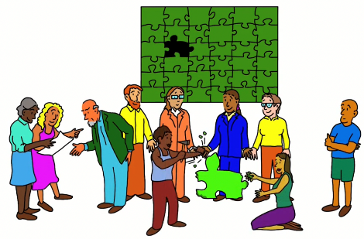 | Relates to Exhibit 26 (Room 4) ‘Creating the best environment’.

Work out how you will create the best environment for the Community of Practice to do its work.

 | Tip |  | What you will do
Find out as much as you can about the participants before the meeting.
Designate a facilitator; if this isn’t you, work out the tone and style of facilitation you want.
Use ice-breakers and creative exercises to help everyone to get to know each other from the start. (But try to match them to context.)
Plan your meeting so it’s a mix of information-giving and exploration, and use a variety of ways to do this so people stay interested and energised.
Plan breaks and don’t be afraid to have more. If it’s face-to-face, get refreshments; if it’s online, suggest everyone has access to some.
You need to set a respectful tone and share some ground rules so people feel valued, safe and useful, and feel able to give and receive critical challenges.
Encourage collaboration and respectful critical conversations. Give everyone time for their view to be heard.
See ‘Tips for the first Community of Practice meeting’ and ‘Tips on facilitation’ in the Top tips display room, and see ‘Setting the right tone’, ‘Creating engagement in meetings’ and ‘Facilitation styles and guides’ in the Storeroom arc-eoe.nihr.ac.uk/ storeroom

Tips on setting success criteria
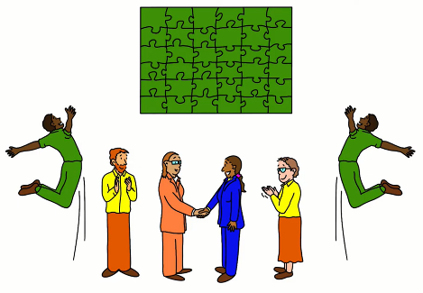 | Relates to Exhibit 28 ‘The goals of the first meeting: planning’ (Room 4) and ‘Tips on setting success criteria’ (in the Top tips display room).
It’s important that the Community of Practice determines its own success criteria to:
- agree and manage their expectations
- judge the impact of the research-based change being made
- guide the timing and scope of this change.

Check your success criteria.

Aligned with the action plan?
Capable of guiding evaluations?
Capable of guiding reporting to key people?
Reflective of the change being implemented?
Taking account of the impact the change will have on all the groups of people involved?
Measurable or assessable in some other robust way?
Achievable?
Associated with clear timelines?

Tips on evaluation
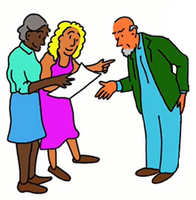 | Relates to Exhibit 33 ‘The goals of the middle meetings’ (Room 5) and ‘Tips on evaluation’ (in the Top tips display room).
Evaluation can be SUMMATIVE (at the end of a project to see how well it succeeded) or FORMATIVE (undertaken at key points during the project, to help it along – e.g. after small tests of change). Evaluations need to match the success criteria you have set.
You need to be clear why each method is relevant and how data are going to be collected, analysed, and used. Be careful not to select burdensome data collections.

Decide what methods you will use.

 | Method examples |  |  | What you will do
Comparing data before and after the research is implemented (e.g. discharge rates).
Rating satisfaction levels using scales or questionnaires.
Watching how people undertake specific tasks.
Checking what’s recorded in notes.
Seeing if aspects of care cost less after the research has been implemented.
After-action reviews (AARs) are useful if you want to evaluate the process of change.
… something else?

Tips on impact assessment and
communication
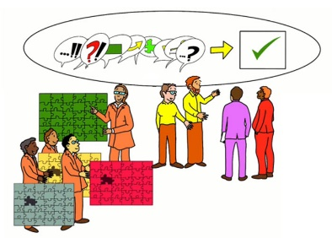 | Relates to Exhibit 37 ‘The goals of the final meeting’ (Room 6) and ‘Tips on impact assessment and communication’ (in the Top tips display room).

Impact assessment
Knowing the impact your work is having, or has had, is critical to successful implementation because it allows you to:
- judge the progress you are making with your implementation project and make necessary changes
- decide if the research you’re implementing could be applied to a wider context and so spread beyond the boundaries of your work
- assess the breadth of the impact your project has made on individuals, teams, units, organisations, and the wider context or society.

Look at the Social Impact Framework (health-policy-systems. biomedcentral.com/articles/10.1186/s12961-018-0375-0 in Supplementary File 8), devised by Kate Beckett and colleagues, and see if it can help with this wider assessment.

Communication

Discuss how best to communicate the impact of your work with the key stakeholders, who may have relevant networks that could be used, and communications specialists in your organisations.

 | Things to do |  |  | Your actions / conclusions
Decide the purpose of your communication.
Decide who you want to tell, what you want to tell them, and how best to convey each message. |  |  | (For example, stories are popular and memorable, but some people prefer just the facts in infographics, so a combination of both might be very effective and efficient at reaching multiple audiences.)
Always use several different media to get to different audiences. |  |  | (For example: Twitter, WhatsApp, email to people individually, a newsletter, a blog or vlog or a YouTube film or a podcast, an article / news item for a practitioner journal or an academic journal.)
Let others take the strain – the communications specialists, for instance, or local press. Give them the information and they’ll create the messages – but do check the messages before they go live!! |  |  | (They may, for example, send out a press release or a letter to your local paper, or contact your local radio station.)
Collect responses and note any you need to follow-up. |  |  | (How will you do this?)
Use your communications to build networks and take the work further. |  |  | (Who can you contact?)
Evaluate your communications – it’s important to see if, and how, they influenced the work. |  |  | (Evaluations range from a simple discussion to a more formal after-action review, see hisengage.scot/equipping-professionals /participation-toolkit/after-action-reviews/, to formal surveys of stakeholders and influencers.)

Appendix: Research implementation:
other approaches
Relates to Exhibit 8 (Room 1).

Which of these recorded lectures are relevant for you to watch? Now? Later? (If so, when?)
Watch the lectures here: arc-eoe.nihr.ac.uk/lectures

The role of context in implementing research evidence (30 mins)  Annette Boaz – Professor of Health and Social Care Policy, London School of Hygiene and Tropical Medicine  This session made a case for the importance of context in implementing research evidence. It argued that research evidence often ‘lands’ in practice settings in a state of bewilderment. Drawing on recent examples of implementing research evidence, it highlighted the wide range of contextual factors that can trip up even the best-laid implementation plans. In particular, it highlighted the role of theory in generating deeper insights into contextual factors. Finally, it considered how research developed in local contexts can sometimes be better equipped to generate research evidence that meets local needs. | Watch?  When?
Engaging people and communities in implementation (54 mins)  Peter Beresford – Emeritus Professor of Social Policy, Brunel University London  The aim of this session was to explore how inclusive involvement, which we often think about in terms of planning, research, and evaluation can also extend to the key stage of implementation in provision and practice. It drew on experience working to achieve this in both user-led and collaborative schemes and initiatives and hopefully enabled us to understand better both drivers and blockers and helped participants address the issue in their own particular work. | Watch?  When?
Implementation from the perspective of a knowledge mobilisation fellow (49 minutes)  Lesley Wye – Senior Research Fellow, University of Bristol  We all want our research to make a difference. But how does that happen? Who needs to be involved? What are the first steps? What helps and what makes it harder? In this talk, NIHR Knowledge Mobilisation Research Fellow Dr Lesley Wye drew on 20+ years of experience of making change happen (and sometimes studying it!) within various sectors including healthcare, commissioning, charities, and even the NIHR itself. | Watch?  When?
Introducing the DEEP approach to knowledge mobilisation (54 minutes)  Nick Andrews – Research Officer, Swansea University  It is important to understand that Developing Evidence-Enriched Practice (DEEP) is an approach to knowledge mobilisation, not a method or intervention. It is as much about ways of being as it is about ways of doing, and was developed through a participatory action research project funded by the Joseph Rowntree Foundation and Health and Care Research Wales from 2014 to 2016. It has since been applied across a range of local authorities, social care, and community organisations in Wales and Scotland. | Watch?  When?
Experience-based co-design: its role in implementing research (51 minutes)  Glenn Robert – Professor, King’s College London  This seminar critically explored the current trend towards more participatory methods for implementing change within (and outside) healthcare organisations, and the resulting opportunities and challenges that arise for applied (and not so applied) researchers. By revisiting the radical origins of methods such as Experience-based Co-design, the talk explored the potential for combining both creativity and rigour in implementing research findings to improve the delivery and organisation of healthcare services. | Watch?  When?
The practical implications of Normalisation Process Theory for the implementation of research (54 minutes)  Carl May – Professor of Medical Sociology, London School of Hygiene and Tropical Medicine  Implementation research looks for answers to some of the most difficult problems that we face: how to get new and improved evidence-based ways of delivering and organising healthcare into practice, and how to keep them there. At the same time, implementation researchers have worked to develop frameworks that help us understand, organise and evaluate the processes of implementing innovations and evidence. Normalisation Process Theory (NPT) is an example of such a framework: there are now around 400 protocols, reviews and empirical studies that have applied NPT, not just in healthcare research but in areas as diverse as agriculture, education, criminal justice, and supply chain logistics. This seminar provided participants with an introduction to NPT and an understanding of how to apply it to practical problems in implementation. In particular, it was oriented to action. NPT focuses on the things that people do, rather than their attitudes or intentions, and it emphasises the collaborative nature of implementation work. | Watch?  When?
Arts-based knowledge mobilisation (52 minutes)  Kate Beckett – Research Fellow, University of the West of England  With the help of an EPPIC film (all is explained!), Kate Beckett explores the potential of Arts-Based Knowledge Translation strategies (ABKTs, e.g. participatory drama) to catalyse change by stimulating debate and knowledge sharing among key healthcare stakeholders. ABKTs simultaneously evoke rational and emotional processing. They provide a social milieu for diverse evidence to be collectively interrogated and new ideas actively tested. The transformative potential of such productive interaction was also explored with reference to the ‘Social Impact Framework’. | Watch?  When?
The place of implementation science in practical research implementation (51 minutes)  Paul Wilson – Senior Lecturer, University of Manchester  Challenges in getting evidence into practice in health systems have long been recognised, but have become a key concern of health systems generally. Grounded in several disciplines, implementation science is the study of strategies to promote the uptake of evidence-based interventions into healthcare practice and policy. An ever-growing body of evidence on uptake and adoption now exists, but many important messages that can inform implementation efforts in practice remain buried in the academic literature. This presentation considered the challenge of getting not just evidence into practice but also implementation science into practice. | Watch?  When?
Covid-19 and the unhinging of research implementation: all change, please (1 hour)  Trish Greenhalgh – Professor of Primary Care Health Sciences, University of Oxford  Covid-19 has changed science – perhaps forever. This has huge implications for getting research into practice. The pandemic and its aftershocks have shaken the traditional pillars supporting dispassionate inquiry, academic reporting, dissemination, and implementation. How to buttress these crumbling pillars? This lecture considered four approaches that can be taken by individual academics: reflexivity (heightening awareness of one’s identity, values, and ethics as a scientist), painful engagement (understanding the damaging interaction between science, ideology, and politics, and highlighting potential avenues for damage limitation), epistemological labour (defending the credibility of our science by defending our assumptions – and challenging competing assumptions – about the nature of reality and how that reality might be known), and deconstruction (transcending the distortions produced by others’ language through recognising and actively seeking to circumvent the constraints of discourses and linguistic conventions). This all changes how researchers influence policy and practice. | Watch?  When?
All you ever wanted to know about the Knowledge to Action Framework (1 hour)  Ian Graham – Professor and Senior Scientist, Ottawa Hospital Research Institute  This presentation reviewed the origins of the Knowledge to Action Cycle, explained its components, and described how it has been used. A case study was presented to illustrate how the framework can be used in the real world to plan implementation, evaluation, and sustaining of evidence-informed practice. | Watch?  When?
Design practice and implementation (35 minutes)  Joe Langley – Principal Research Fellow, Design Research Lab4Living, Sheffield Hallam University  Design, Co-Design and Design Thinking are now ubiquitous terms, all widely used beyond the discipline of Design. Some tools, methods and mindsets of Designers have been adopted along the way. The practices of Designers have been left behind.  In this seminar, Dr Joe Langley talked about the practices of Designers, the impact they have on Co-Design, and the potential contribution they hold for implementing research evidence.  Through case studies, we looked at Design and Co-Design from a Designers’ perspective, illustrating how Design practices are used to explore problems, develop solutions and communicate across boundaries, engaging with people mentally, physically and emotionally – which is essential to influencing behaviour. | Watch?  When?
Promoting Action on Research Implementation in Health Services: the life and times of the PARIHS framework (34 mins)  Jo Rycroft-Malone – Professor and Dean of the Faculty of Health and Medicine, University of Lancaster  The Promoting Action on Research Implementation of Health Services (PARIHS) framework explains the successful implementation of evidence (in its broadest sense) as a function of the nature of that evidence, the context in which evidence is intended for use, and the approach to facilitation. In this discussion, Professor Rycroft-Malone unpacks the premise, content and use of the framework – including a reflection on how frameworks such as PARIHS do and do not get used in implementation research. | Watch?  When?
Mindlines (final title and duration tba)  Andrée le May and John Gabbay – Former Implementation co-leads, ARC EoE; Honorary Senior Visiting Fellows, Cambridge Public Health; Emeritus Professors, University of Southampton  We describe how and why the mindlines model came about, and explain the concept and its relevance for implementing research.. | Watch?  When?

Appendix: The Badchester Chronicles
A case study in implementation. All the main incidents and characters in this case study are drawn from real events, but they have been fictionalised to protect the innocent!
If you circulate these for group discussion, don’t give them out all the episodes at once. It’s best if people have to address the questions without knowing how the story develops.

Episode 1: Welcome to Badchester, the Luncashire
hot spot
In which we meet the main players – but the GP sends apologies.
People with chronic obstructive pulmonary disease (COPD) experience shortness of breath and coughing even when they are relatively well. They are vulnerable to frequent chest infections (‘exacerbations’) that not only make those symptoms much worse but are hard to treat effectively. Moreover, each exacerbation increases the lung damage and worsens the long-term prospects.
At Luncaster Medical School, Mo, a Senior Lecturer in Respiratory Medicine, has just had a systematic review published in Thorax. His review shows beyond any further doubt that pulmonary rehabilitation can improve the health of people with COPD, maximising their lung function and minimising the number and severity of exacerbations. It is not only clinically effective but also cost effective.
At the Respiratory Unit’s celebration of this academic success, someone mentions a recent audit at South Badchester Hospital (in central Luncashire) which has shown that too few patients with COPD are being referred by their GPs for pulmonary rehabilitation, resulting in excessive (and expensive) hospital admissions for COPD exacerbations. He arranges to meet the lead of the Badchester community-based team of respiratory nurses, Immy, and they agree to design and lead the implementation of a scheme to improve the referral rates for pulmonary rehab. What is now needed is to persuade the local population and their health professionals of the benefits of early pulmonary rehabilitation.
Immy emails Felicia, an experienced community nurse from her respiratory team, who once did an MBA and has good organisational skills. She invites Mo, not just as the researcher whose work they want to implement, but also in his capacity as the hospital consultant responsible for the Badchester pulmonary rehab services. Finally she asks Jo, a GP known to be interested in this problem. They all agree to help to get this implementation project underway and they set a date for the four of them to meet as a preliminary design group to steer the project.
The week before the meeting, however, Jo sends apologies….

Questions to consider
Imagine you’re in Immy’s place. Should the meeting go ahead without Jo the GP?
How else would you have convened this group to help design the project? Would you have invited anyone else?
What would be your agenda for that first meeting?

Episode 2: The ‘design group’ find their MoJo
In which they decide to have a go – if they can work out how.
The first meeting of the design group eventually takes place with Jo there. Mo, the hospital consultant, lays out the research evidence and answers questions from the others. Bert, a retiree who has COPD, has also now been invited onto the design group, and – having experienced pulmonary rehab – is particularly vocal and enthusiastic. Before the end of the meeting, Felicia introduces some materials from her MBA days that explain how Communities of Practice could help take this forward. They agree not only to give the method a go, but to try and learn a bit more about the method before the next meeting.
They agree the following.
- It would indeed be a good idea to improve the levels of pulmonary rehabilitation in Badchester.
- They will use Communities of Practice as a way to bring together key stakeholders and enthuse the change to the service in line with the research evidence.

Questions to consider
What more does the design group still need to do? How would you help them do that?
Does anyone else need to join it?
What might they all do before their next meeting?

Episode 3: Stop? Go? Pause?
In which the group get cold feet.
By the time of their second meeting, the members of the design group have taken soundings across their various networks and they are getting cold feet: too many hard-pressed / resistant GPs out there, and no sign yet of getting extra funding to run the implementation. They are on the point of abandoning the project, especially when Jo, the GP, announces that she’s emigrating. But, she adds, she’s talked to an influential GP, Sowoomi, who has always appeared very sceptical about primary care spirometry, and to everyone’s surprise he has asked to join the design group. This gives them hope so they agree to meet again and invite him along.
The third meeting is a bit stormy, but it eventually becomes clear that the sceptical Sowoomi is in fact quite well-disposed to pulmonary rehab. He has always, however, been annoyed at how the service has been run, at the lack of time available for his practice’s nurses to identify patients from their (very hard to search) computerised records, and also at the lack of training for them on how to do spirometry. He is also rather intrigued when Mo, the hospital consultant, waxes lyrical about the Community of Practice materials he has finally got round to looking at. So Sowoomi agrees to join the Community of Practice as long as it aims to sort these problems out.
They agree in principle that part of the task will be to get the message out that it is demonstrably better to improve GP and community nursing care than to wait to treat exacerbations of COPD, which are hard to alleviate and often inflict further lung damage. However, they are floundering a little because they are not sure (a) how best to do that, and (b) what else they might need to do.

Questions to consider
How might the design group begin to answer those questions?

Episode 4: A CoP for COPD
In which they get it together and convene a Community of Practice.
At its fourth meeting, the design group – to which they have invited Premila, one of Badchester’s leading practice managers, and also Hetty, a health promotion specialist – agree to focus on two aspects of the implementation:
- devising a better scheme to help the local practices identify their COPD patients, carry out spirometry and any other necessary tests, and then refer them to for pulmonary rehabilitation as appropriate
- mounting a public campaign to promote the benefits of pulmonary rehabilitation.
Having thought carefully together about the stakeholders, they nominate people to invite onto the Community of Practice (16 names altogether) and Immy agrees to email an invitation to them all. They set a date for the first meeting and arrange to bring tea and cakes.
What could possibly go wrong?

Questions to consider
Is it the design group’s job to make such definitive decisions, or should they have left that for the Community of Practice to decide?
If you were in their shoes, what kinds of people would you invite to the Community of Practice, and why? (What might you expect from the various members and what would be in it for them?)
What should the invitation letter to potential members of the Community of Practice say? Do you agree that a letter should come from the lead for this implementation project, or might there be other ways to approach the potential members?
What other preparations would you make before the first Community of Practice meeting?

Episode 5: A top-down dousing
In which the Community of Practice comes together – and falls apart again.
Twelve people have turned up, not all of whom know each other, although they are all involved in community respiratory care. Immy, Mo, Sowoomi, Hetty, and Premila, are there, and as well as Felicia there are two further community respiratory nurses. Two patients, Brenda and Bruce, belonging to a local charity called BreatheAble, have joined Bert. Two additional GPs were invited, but only one has turned up. Among others who haven’t come are the Director of Public Health and a member of the Luncashire commissioning team.
The Community of Practice members who weren’t in the design group aren’t quite sure what is expected of them, but they look expectant. Immy tries an icebreaker, but it doesn’t quite work and, as the minutes go by, she worries that things are already going wrong. However, when she and Mo make their presentation showing (a) how strong the evidence is for the benefits of pulmonary rehabilitation and (b) how few patients attend in Badchester, the room begins to tune in again. Once Bert, Brenda and Bruce have also had their say, explaining how it benefitted them, everyone seems convinced. Something must be done.
Then half an hour into the meeting, the Director of Public Health, Philomina, arrives late, and Immy quickly brings her up to speed. “Oh good,” thinks Philomina, “this could help me hit one of my KPIs.” Philomina explains that the Badchester Health Board and her CEO have this problem firmly in their sights, and announces that she would like to use this group to help her set targets to improve respiratory care provision and to advise her on how best to monitor them.
The mood in the room changes. There is a clear feeling of disgruntlement; this was not what they came to hear. Sowoomi is seething.

Questions to consider
How could Immy and her design-group colleagues have avoided this setback?
What they should do now?

Episode 6: Bunfight at the CoP corral
In which there is a frank exchange of views.
Immy calls a short comfort break and, over the coffee and cakes, Mo and Immy explain to Philomina that the group isn’t ready yet to think about targets, and that there is a plan for this and subsequent meetings. Sowoomi joins them and makes a scathing comment about top-down targets and the lack of resources. Felicia has overheard this exchange and whispers to Immy on the way back to the room: “If things aren’t going well, Iet me help”.
When they reconvene, Immy begins to explain how the Community of Practice will work. She notices Philomina’s not really listening but looking daggers at Sowoomi, who sits with arms folded. Felicia also picks up on the body language and shoots a look towards Immy who pauses. “Felicia …”, she says, “you look like you want to say something.”
“Yes, thanks,” says Felicia, “well spotted! I’m feeling rather confused. You are explaining, Immy, how we are all going to work together to solve the problem of low referrals, but before the break it sounded as though our task will be to agree how to set targets, which I don’t really think it’s our place to do. Perhaps before we carry on, we should clarify this.” Then she adds, “I’d love to hear how Sowoomi feels…”
Sowoomi, reminding everyone that he speaks as a GP whose task it is to make the referrals, calmly but forcefully explains the problems that they have had with the current system. He argues that no amount of top-down pressure will help until those problems are tackled.
Lots of people are nodding and Immy invites the other GP and the nurses to briefly comment. When they have added their support, Immy then asks Philomina to talk them through the Health Board’s views on this. Philomina explains the pressure that they are under to meet the Department of Health and Social Care targets. When she’s finished, Bert volunteers that it’s all very well setting targets, as he knows from when he worked in the steel industry, but that he also knows that there was never any chance of meeting them unless the shopfloor production processes were right.

Questions to consider
It was a big risk to open up a discussion about the main underlying bone of contention. What do you think would have happened, had they not done so?
Immy made use of what she had learned during the design phase about Felicia’s facilitation skills and Sowoomi’s commitment to what the Community of Practice was trying to do, despite (or maybe because of) his annoyance at the current system. How critical was this awareness? What do you think would have happened, had she not had this knowledge?

Episode 7: Moving on
In which the Community of Practice goes back to basics – and moves forwards.
Sensing that the tension has been released, Immy suggests that before going further the group begin sharing their views about the benefits and drawbacks of having a better pulmonary rehab service.
Within twenty minutes of coloured pens flying across flip charts, it becomes clear that no-one thinks it’s a bad idea; they just see a lot of obstacles to helping it to happen. In the course of that discussion, it becomes clear that primary care practices across Luncashire are divided in their support, but that resistance would melt if they were to receive additional funding from the Health Board for their practice nurses to take on the work of identifying patients and undertaking the spirometry. This could be the necessary incentive for them to get involved.
Before drawing the meeting to a close, Immy asks if there any other stakeholders or influencers who need to join the Community of Practice for next time. Philomina, who has been silently listening to the discussion, says she will make sure that someone from Luncashire Health Board comes along. Sowoomi says he’ll also bring a practice nurse. The mood seems good when they agree the date and time for the next meeting, when they will begin by understanding the context better together.

Questions to consider
If you were on the design group, what would you plan to do in the next meeting(s)?

Episode 8: A tricky context to work in
In which the difficulties of the situation become clear.
At the second meeting (14 attend) Immy and Felicia are explicitly working together as facilitators. They have agreed to start by getting the Community of Practice to think about the context.
The emerging picture is that COPD is very prevalent but often under-recognised and under-treated. This is partly because older people who grew up and worked in Luncashire, which used to be a coal-belt county whose levels of economic deprivation now reflect the defunct mines and heavy industry, see chronic cough as just an inevitable and often stigmatised part of being old (and poor) in Luncashire. Patients and doctors alike have little faith that pulmonary rehabilitation can do much to alleviate it. Most of the elderly patients with COPD have a misplaced faith in antibiotics as “curing” the COPD exacerbations and many local GPs reinforce that view by prescribing them almost on demand.
Meanwhile the Department of Health and Social Care are demanding that Luncashire antibiotic prescribing rates come into line with the much lower national levels, and the Badchester Health Board requires the GP referrals for pulmonary rehab to improve markedly. Badchester is having to make £2m savings across the board, and the hospital is under pressure from lengthening waiting lists. The public health department in the local authority has been mounting a series of “Healthier Luncashire” social marketing campaigns, focussing mainly on diet, exercise, and substance abuse and has funds to do more.
The attempts by the community-based respiratory nurses to persuade GP practices to identify patients and carry out spirometry have been demoralising. When they visit practices, they are usually met with scepticism, sometimes even hostility. This has partly been because – in order to try and hit the targets – they are being asked to deal with the worst “offenders” first, whereas their instinct is to “work with the willing”. As the nurses tell their sorry tales (one of them, Natia, is close to tears as she speaks), the Health Board Commissioner seems to be listening intently and whispers something to Philomina, who nods. Immy, meanwhile, is feeling quietly embarrassed. As the head of the respiratory nursing team, it’s been her determined policy to get her nurses to focus on the poorly-performing GP practices.

Questions to consider
What are the main obstacles and opportunities you foresee?
How would you move ahead, if you were in their shoes?

Episode 9: Agreeing a way forward
In which the Community of Practice works out an implementation plan.
Sowoomi then suggests there are two ways to get GPs to change.
- Rather than sending the respiratory nurses in “cold”, they should persuade a few key practices to get involved (“Yes, Natia, you’d finally be working with the willing!”). Then if they can show it works, those GPs are bound to use their influence among their peers, which will open doors for Immy’s team.
- Above all, they should ensure that, once a practice has received the training in searching their database for COPD patients and doing the necessary tests such as spirometry, they receive additional resources to do the task. With that incentive, he says, it might just work. Premila strongly backs him up.
Before the meeting finishes, Immy and Felicia work together to help the group agree the outlines of an implementation plan to move things forward. Within a mere 20 minutes, where they ask everyone to suggest one possible action that the group could take, they have gathered lots of ideas. Using a simple consensus method (Nominal Group Technique) that Felicia learnt in her MBA, the following four priorities emerge.
- The community respiratory nursing team should stop focussing its efforts on the poorly performing GPs, and should work initially with a small group of enthusiastic practices to design a training programme that they will accept.
- The Community of Practice needs to work out how to spread the message generally among the primary care professions that it is demonstrably better to improve GP and community nursing care than to wait to treat exacerbations of COPD.
- One of the next tranche of social-marketing campaigns should be aimed at helping patients and the public recognise the benefits of preventing COPD exacerbations rather than taking antibiotics when they develop.
- There should be a concerted effort to explore how extra resourcing might be found to support this work.
They collectively agree that the design group will think a bit more about how to take these forward before the next Community of Practice meeting.
As the meeting closes, only five minutes overtime, there is quite a buzz in the room; people stay and chat in small huddles. Immy and Felicia collect all the flipcharts and agree to meet over a take-away pizza to write them up and circulate the conclusions as soon as possible.

Questions to consider
Have they bitten off more than they can chew? (This refers to their prioritised actions, not the pizza.)
What can the design group do to make sure that this initial enthusiasm doesn’t evaporate?

Episode 10: How do we make it happen?
In which the design group finds some unexpected support for the work of the Community of Practice.
The design group (now just Immy, Felicia, Sowoomi, Hetty, Mo, and Bert) reconvene a week later and collectively gulp at what they seem to have taken on. Although feeling quite energised by what happened at the Community of Practice, there is also a deep sense of “where do we go from here?”
Hetty perks them up them up by telling them that Philomena and the Luncashire Commissioner have already spoken to the relevant people at Badchester Health Board, who have been using a social-marketing company. They have agreed to look into doing a COPD social marketing campaign. Moreover, the advice they have had is that this could also include a series of events aimed at healthcare professionals. So that’s Priorities 2 and 3 already possibly taken care of. Smiles all round. They agree to invite Connie, the Badchester Communications Director, to the next meeting of the Community of Practice.
Immy, who of course had been insisting for years that the demoralised community respiratory nurses work with poorly performing practices, somewhat sheepishly admits that she has had a meeting with her team and accepted the suggested shift towards “working with the willing”. There’s laughter as Sowoomi ribs her with “What took you so long?” He says he can name a handful of GPs who he thinks would be up for this. They set up a small working group comprising Natia, Sowoomi’s practice nurse, Premila, and the second GP; their role will be to set up the new programme of work with those GPs.
There remains, however, Priority 4: the vexed question of funding. They toss a few ideas around and agree to go away and explore a few avenues including the local Chamber of Commerce and Probus groups; Bert is a committee member on both. Mo looks pensive. “What’s up?” asks Felicia. “I was just thinking about a visit we had recently at the Respiratory Unit from a company called Inspirometrics…” he muses. “They want to sell more spirometers. Perhaps we shouldn’t have given them such short shrift after all”.

Questions to consider
Is there anything else that the Immy, Felicia, Hetty, Sowoomi, Mo, and Bert need to do before the next meeting?

Episode 11: How will we know we’ve done it?
In which the Community of Practice finds that they might just succeed after all.
At the third meeting of the Community of Practice, only three people besides the design group turn up, which seems disappointing given the previous buzz. But the people who were most active at the previous meeting are mostly there, plus Connie the Badchester Communications Director.
Sowoomi updates them on the plans for the GP working group. Then Hetty delivers the good news that Badchester Health Board are minded to run a social-marketing campaign and have committed to mounting a series of events for primary and community care staff. Connie tells them about the @easybreathers social-media campaign she is working on.
Felicia stands at the flipchart and asks: how will we know in a year’s time whether we have succeeded? Someone quips “We won’t! Not unless we get some resources to do all this!”
“Funny you should mention that…” says Mo. He announces that Inspirometrics have agreed to fund a peripatetic spirometry trainer, as it’s in their interests to see this scheme succeed. Philomina then also announces that she is now trying to persuade the Luncashire commissioners to set aside a modest fund to promote pulmonary rehab in the next round of contracts. After all, this should help both to reduce unnecessary hospital admissions and to meet the DHSC targets for reduced antibiotic prescriptions. Then Bert proudly announces that one of his Probus chums, whose mum has COPD, is President of the local Rotary. A proposal for a fund-raiser is on the agenda at the next Rotary dinner.
The Community of Practice spend the rest of the meeting thrashing out what they think will be good indicators of the success of their work, if they were to assess progress in a year’s time. They also agree to use some of these indicators to check progress over the coming months and make any necessary adjustments to the scheme.

Questions to consider
Does it matter that they are only agreeing their success criteria this late in the day?
What blend of quantitative and qualitative indicators would you suggest they use to assess whether the re-invigorated pulmonary rehab scheme is successful?
Which of your suggested indicators would also help them make adjustments if things aren’t working out as planned?

Episode 12: From South Badchester clinic to all of Luncashire
In which the project goes county-wide.
The design group (now usually just Immy, Felicia, and Sowoomi) continue to meet as the new schemes get underway. Six months in, they arrange a Community of Practice meeting to bring people up to date, celebrate achievements, and iron out any emerging problems.
Only six people attend. They hear how the social marketing and social media campaigns have taken off nicely, but that it seems the community nurses are struggling a little with helping GP practices to review their databases to identify COPD patients. Bruce, who is involved with the charity BreatheAble, suggests a way forward using the good offices of the IT whizz who runs the database there. They agree that, as everyone is busy, they won’t hold any more Community of Practice meetings to monitor progress, and that the Design group (well, Immy…) will email round a brief quarterly newsletter instead.
A further six months on, the newsletter reports that they have doubled the referral of Badchester patients for pulmonary rehabilitation and significantly reduced the numbers of avoidable hospital admissions. 78% of Badchester GP practices have undergone the patient-identification and spirometry training, and surveys of the patients they have referred for pulmonary rehab show that most patients report the benefit and appreciate its value.
The Luncashire Commissioning Board has decided to upscale South Badchester’s success and has agreed to fund a network of six pulmonary rehabilitation units in community health centres across the entire county, to be run by BreatheAble.
Immy and Felicia ask all the original invitees of the Community of Practice to a meeting to (a) celebrate what they have achieved and (b) help pull together a short paper to go to the Luncashire BreatheAble Planning Group, advising them on some of the lessons they have learnt on the way.
Of the original 16 invitees, 12 come to the meeting. Afterwards there is a reception for 80 people to mark the launch of the new Luncashire initiative. The buffet (a lunch launch) is generously hosted by Inspirometrics. There are short speeches from the CEO of Luncashire Commissioning Board (soon to be Luncashire ICS), the Chair of the Badchester Health Board, and the President of Badchester Rotary. Connie uses her contacts to ensure that the Luncaster Echo runs a big splash on page 2, and that interviews with BreatheAble folk are the main feature on the morning phone-in on Luncaster FM (“for all your local Luncashire listening”).

Questions to consider
What went right?

